|  |  |
| --- | --- |
| Name : Darrel S. Jabonillo | Section : BSIT 3C |
| Assignment No : 2 | Submission Date : March 23, 2024 |
| Assignment Title: Rock, Paper, Scissor | |

**Code :**

**HTML FILE**

<!DOCTYPE html>

<html lang="en">

<head>

<meta charset="UTF-8">

<meta name="viewport" content="width=device-width, initial-scale=1.0">

<title>Rock Paper Scissors</title>

<link rel="stylesheet" href="styles.css">

</head>

<body>

<h1>Rock - Paper - Scissors</h1>

<div class="choices">

<button onclick="playGame('rock')">👊</button>

<button onclick="playGame('paper')">✋</button>

<button onclick="playGame('scissors')">✌</button>

</div>

<div id="playerDisplay">PLAYER: </div>

<div id="computerDisplay">COMPUTER: </div>

<div id="resultDisplay"></div>

<div class="scoreDisplay">Player Score:

<span id="playerScoreDisplay">0</span>

</div>

<div class="scoreDisplay">Computer Score:

<span id="computerScoreDisplay">0</span>

</div>

<script src="script.js"></script>

</body>

</html>

**JS FILE**

const choices = ["rock", "paper", "scissors"];

const playerDisplay = document.getElementById("playerDisplay");

const computerDisplay = document.getElementById("computerDisplay");

const resultDisplay = document.getElementById("resultDisplay");

const playerScoreDisplay = document.getElementById("playerScoreDisplay");

const computerScoreDisplay = document.getElementById("computerScoreDisplay");

let playerScore = 0;

let computerScore = 0;

function playGame(playerChoice){

const computerChoice = choices[Math.floor(Math.random() * 3)];

let result = "";

if(playerChoice === computerChoice){

result = "IT'S A TIE!";

}

else{

switch(playerChoice){

case "rock":

result = (computerChoice === "scissors") ? "YOU WIN!" : "YOU LOSE!";

break;

case "paper":

result = (computerChoice === "rock") ? "YOU WIN!" : "YOU LOSE!";

break;

case "scissors":

result = (computerChoice === "paper") ? "YOU WIN!" : "YOU LOSE!";

break;

}

}

playerDisplay.textContent = `PLAYER: ${playerChoice}`;

computerDisplay.textContent = `Computer: ${computerChoice}`;

resultDisplay.textContent = result;

resultDisplay.classList.remove("greenText", "redText");

switch(result){

case "YOU WIN!":

resultDisplay.classList.add("greenText");

playerScore++;

playerScoreDisplay.textContent = playerScore;

break;

case "YOU LOSE!":

resultDisplay.classList.add("redText");

computerScore++;

computerScoreDisplay.textContent = computerScore;

break;

}

}

**CSS FILE**

body{

font-family: Arial, sans-serif;

font-weight: bold;

margin: 0;

display: flex;

flex-direction: column;

align-items: center;

}

h1{

font-size: 3.5rem;

color: hsl(0, 0%, 20%);

}

.choices{

margin-bottom: 30px;

}

.choices button{

font-size: 7.5rem;

min-width: 160px;

margin: 0 10px;

border-radius: 250px;

background-color: hsl(200, 100%, 50%);

cursor: pointer;

transition: background-color 0.5s ease;

}

.choices button:hover{

background-color: hsl(200, 100%, 70%);

}

#playerDisplay, #computerDisplay{

font-size: 2.5rem;

}

#resultDisplay{

font-size: 5rem;

margin: 30px 0;

}

.scoreDisplay{

font-size: 2rem;

}

.greenText, #playerScoreDisplay{

color: hsl(130, 84%, 54%);

}

.redText, #computerScoreDisplay{

color: hsl(0, 84%, 60%);

}

**SCREENSHOT**

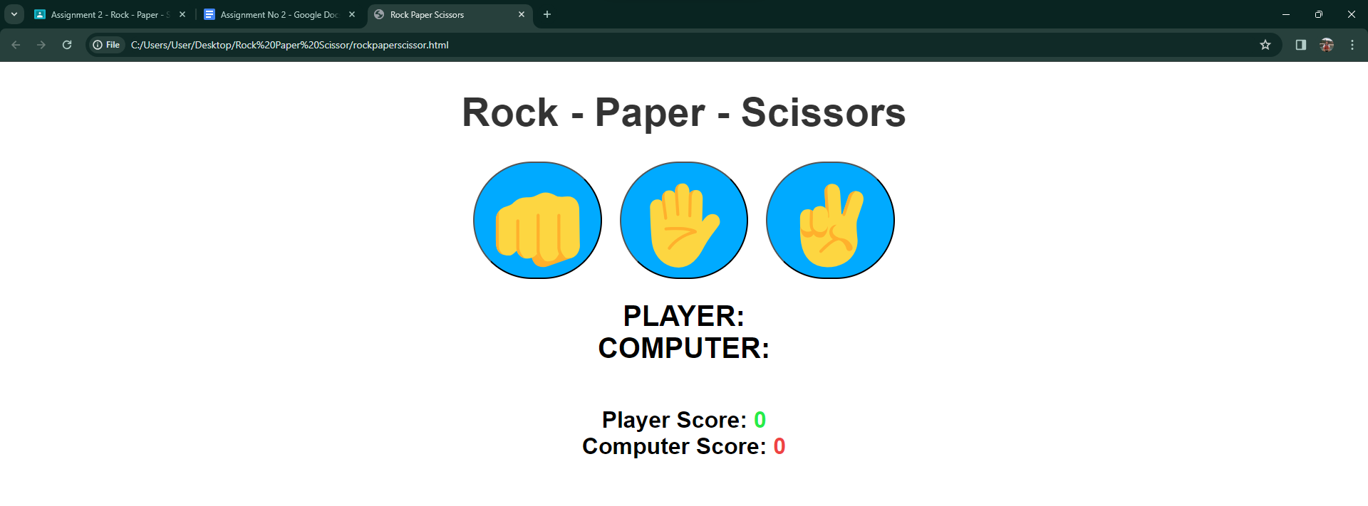

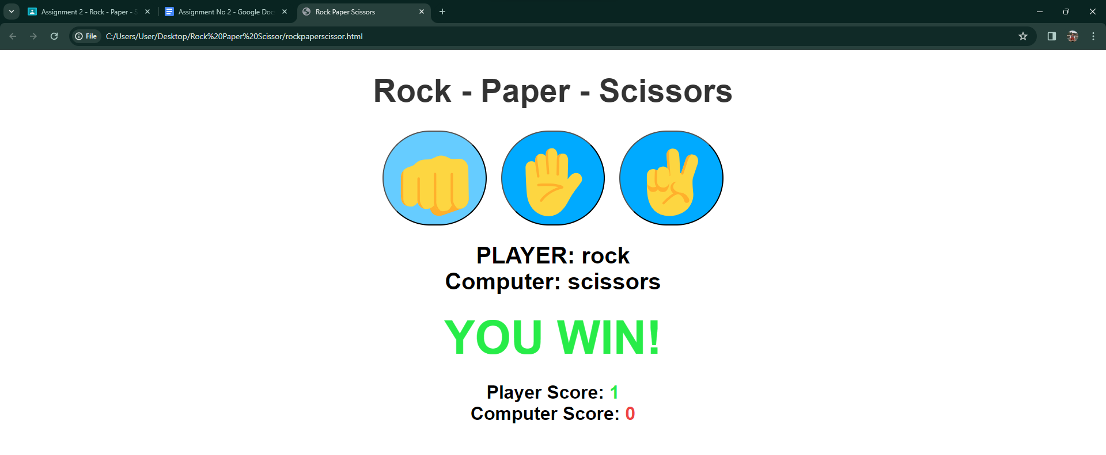

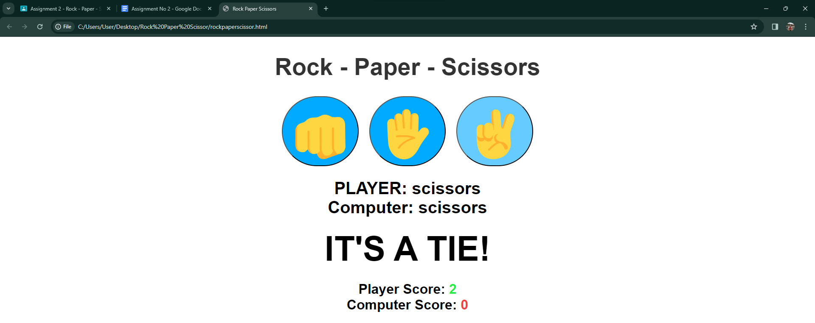

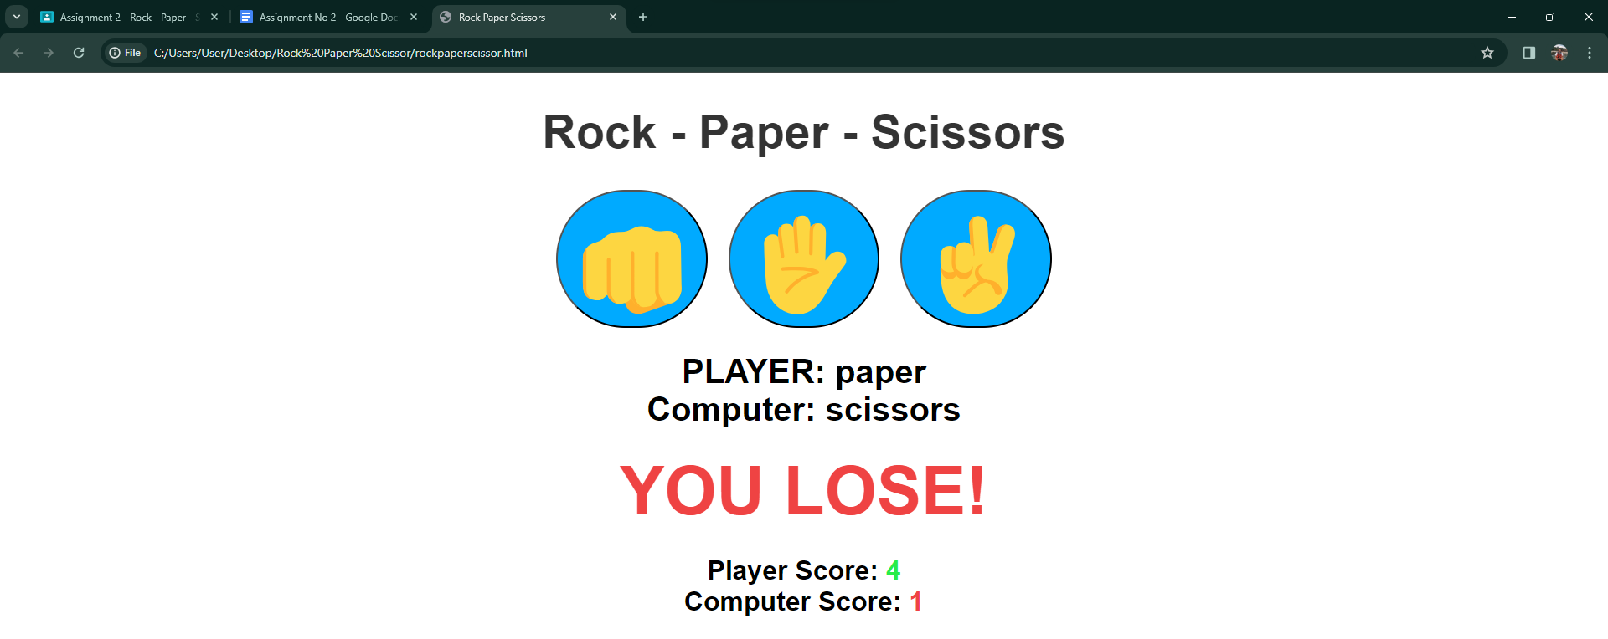

**Dictionary:**

**const** - keyword that defines a variable or pointer as unchangeable\

**let** - variable declaration

**switch** - executes a portion of code depending on the situation and part of JavaScript's "Conditional" Statements.

**function** - is a block of code designed to perform a particular task.

**script src** - point to an external JavaScript file